Great Shakeout Earthquake Drill / Personal Safety
Week 3: October 15 – October 19
Social Media Posts
Post 1
Know how to protect yourself from earthquakes, whether you live, work, or travel to an area where earthquakes are common. Practice earthquake safety with your community - join the Santa Clara County Office of Education in Great ShakeOut Earthquake Drills today: http://www.ShakeOut.org/register
Post 2
Are you prepared? What we do to prepare now, before the next big earthquake, will determine how well we can survive and recover. Register for Great ShakeOut Earthquake Drills at www.ShakeOut.org/register to join the Santa Clara County Office of Education in practicing earthquake safety.
Post 3
When the ground starts to shake, what do you do? If it involves a doorway, a triangle, or running - these are not earthquake-safe actions. Register now at www.ShakeOut.org/register to learn more about Drop, Cover, and Hold On and practice updated earthquake safety actions with the Santa Clara County Office of Education.
Post 4
Take your #ShakeOut drill a few steps further! Find out how you can secure your space, organize disaster kits, and minimize financial hardship with the Seven Steps to Earthquake Safety: www.EarthquakeCountry.org/sevensteps
Post 5
Personal Safety Tips
To ensure your personal safety, whenever possible:
- Upon arrival at work, be aware of your surroundings while parking (especially if it is dark) and immediate put your SCCOE badge on.
- Never leave valuables in your car or in plain sight.
- Avoid carrying a lot of items in your hands when you are walking to and from your vehicle
- Avoid talking on phone and texting while walking to and from your vehicle.
- Do not prop building exterior doors open.
- When at your work station, be sure to secure your personal belongings and valuables.
- When walking at lunch, be sure to firmly grip your purse or secure your wallet in your front pocket to avoid theft.
- Keep an eye out and report any potential work hazards – spills, electrical cords, broken furniture, etc.
- Listen to your sixth sense. If you feel uneasy about a situation or a person, call for help or report the suspicious situation to the police.

Newsletter “Blurb” Articles
Article 1
The International ShakeOut Day, every third Thursday of October, is a day of individual and community events featuring the largest earthquake drill ever, organized to inspire others to get ready for big earthquakes, and to prevent disasters from becoming catastrophes. What we do to prepare now, before the next big earthquake, will determine how well we can survive and recover. ShakeOut will occur in houses, workplaces, schools, and public spaces at 10:18 a.m. on October 18, 2018.
Register at www.ShakeOut.org/register to involve your family or organization. You will receive information on how to prepare for earthquakes and what actions to take during and after the shaking, as well as other ShakeOut news and updates. You can also see who else is participating in your community at http://www.ShakeOut.org/whoisparticipating.

Article 2
At 10:18 a.m. on October 18, 2018, millions of people will participate in the largest earthquake drill ever: ShakeOut! Why? Earthquakes can happen anywhere you work, live, or travel, which is why everyone, everywhere should know how to protect themselves should an earthquake occur.
Register at www.ShakeOut.org/register to practice and improve your level of earthquake safety.

Everyone, everywhere can participate! Individuals, families, businesses, schools, government agencies and organizations are all invited to join with Santa Clara County Office of Education at 10:18 a.m. on 10/18.

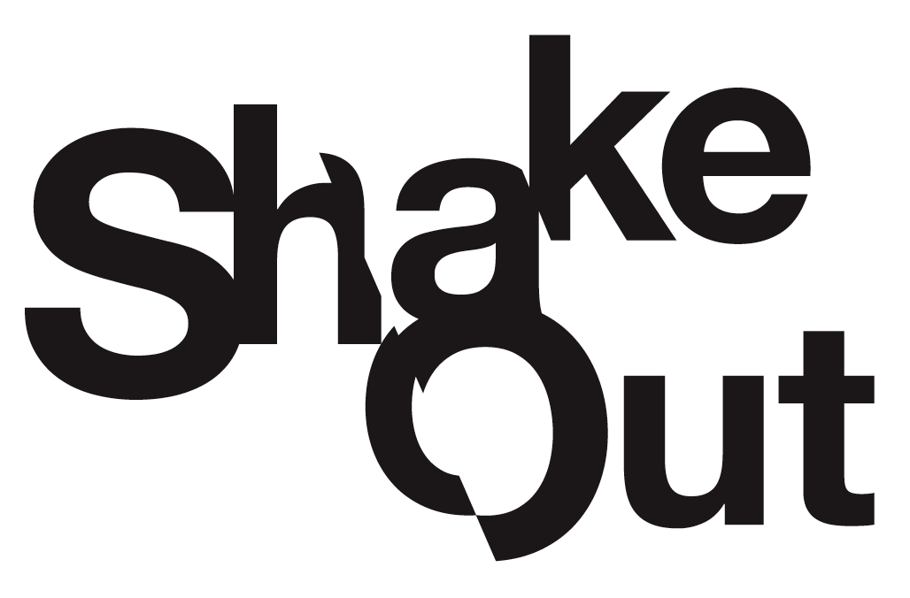
Are You Ready to ShakeOut?
With 318 million people living and working in the United States, a major earthquake could cause unprecedented devastation. What we do now, before a big earthquake, will determine how well we survive and recover.
Great ShakeOut Earthquake Drills in October 2017 involved more than 56.2 million participants through broad-based outreach programs, media partnerships, and public advocacy by hundreds of partners. The drill is held annually on the third Thursday of October. This year, the International ShakeOut Day will be at 10:18 a.m. on October 18.
A key aspect of the ShakeOut is the integration of comprehensive science-based earthquake research and the lessons learned from decades of social science research about why people get prepared. The result is a “teachable moment” on par with having an actual earthquake (often followed by increased interest in getting ready for earthquakes). ShakeOut creates the sense of urgency that is needed for people, organizations, and communities to get prepared, to practice what to do to be safe, and to learn what plans need to be improved.
Not just any drill will accomplish this; it needs to be big. It must inspire communities to come together. It must involve children at school and parents at work, prompting conversations at home. It must allow every organization, city, etc., to make it their own event. We are all in this together.
The 2018 ShakeOut drill will be the largest preparedness event in world history. To participate, go to www.ShakeOut.org/register and pledge your family, school, business, or organization’s participation in the drill. Registered participants will receive information on how to plan their drill and involve others. At the minimum practice "Drop, Cover, and Hold On" at the specified time, which is 10/18 at 10:18 a.m. this year. It is only a one-minute commitment for something that can save your life.

For more information, visit http://www.ShakeOut.org/.

