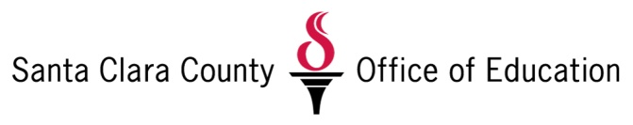

SCCOE Student Attendance Review Board (SARB) Mediations
Dates: 1/11/17, 2/15/17, 3/20/17, 4/19/17, 5/24/17
Times: Kinder-5th grades: 9:00am- - 12:00 pm; 6th-12th grades: 1:30pm-4:30pm
Location: SCCOE (Conference Room TBD)
Audience:
Parents (k-5)
Parents and Student (6-12)
District Representatives
SLS Coordinators

Agenda:
DA SARB Mediation Presentation + Q/A: 30 mins
Behavioral Health Presentation: 30 mins
Substance Use Treatment and Prevention Services: 30 mins
Parent Project: 50 mins

Referral Process and Registration:
Districts will continue “Invitation” Process with DA Letterhead to Parents
Once parents confirm – District will register parent on OMS registration link
Send list of participants to SCCOE

District Participation:
All District representatives should be present at all SARB Hearings to answer any questions that might come up for parents.

